**Project Design Phase-II**

**Technology Stack (Architecture & Stack)**

|  |  |
| --- | --- |
| Date | 14 October 2022 |
| Team ID | PNT2022TMID23510 |
| Project Name | Project – Smart Farmers-IOT Enabling Smart Farming Application |
| Maximum Marks | 4 Marks |

**Technical Architecture:**

Sensor and Devices IBM Cloud User

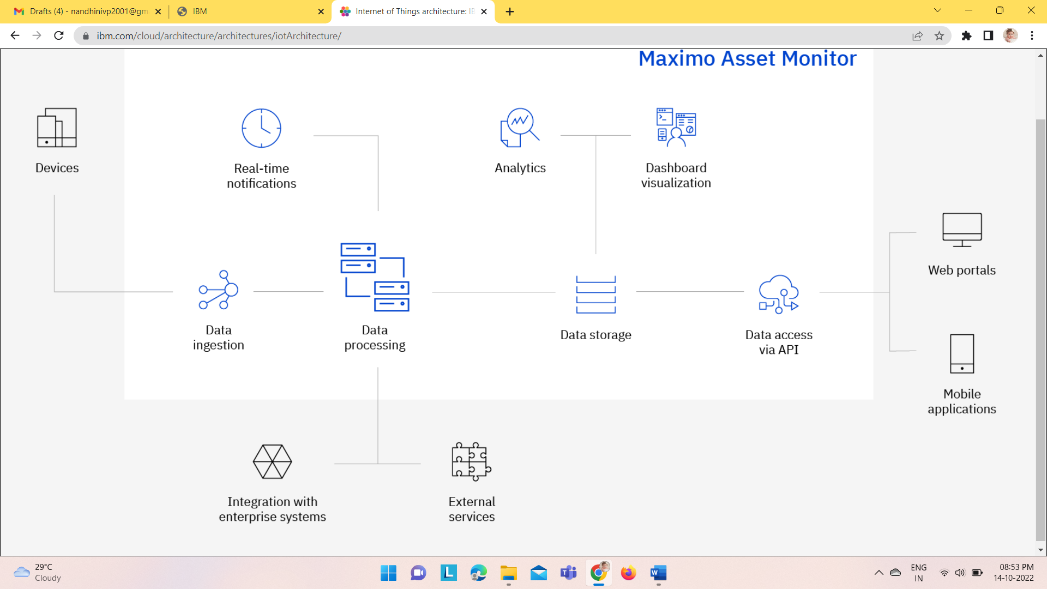

**Table-1: Components & Technologies:**

|  |  |  |  |
| --- | --- | --- | --- |
| **S. No** | **Component** | **Description** | **Technology** |
|  | Mobile Application | Through the mobile application, user get to know all live data from the devices. | MIT inventor |
|  | Web UI | It is used as WebSocket communication in binary mode between the web browser (UI) and your application. | Node red, Python |
|  | IBM Watson | Use your data to create, train, and deploy self-learning models. Leverage an automated, collaborative workflow to build intelligent applications. | IBM Watson STT service |
|  | IBM Watson Assistant | Watson Assistant lets you build conversational interfaces into any application, device, or channel | IBM Watson Assistant |
|  | Ph sensor | It used for sensing the Ph level of the soil | sensor |
|  | Ultra-sonic sensor | It detects the animal movement in the soil | Sensor |
|  | Temperature Sensor | It collects the data of the temperature and humidity of the environment | Sensor |
|  | Soil Moisture Sensor | It collects water level in soil | sensor |
|  | Database | Data Type, Configurations etc. | MySQL, NoSQL, etc. |
|  | Cloud Database | Database Service on Cloud | IBM DB2 |
|  | Cloud Storage | It is used for File and data storage | IBM Block Storage |
|  | Open weather API | It provides highly recognizable weather product that make working with weather data a way easier | IBM Weather API |
|  | Aadhar API | It can authenticate the Aadhaar cards of any other individual without any issue | Aadhar API |
|  | Infrastructure (Server / Cloud) | Application Deployment on Local System / Cloud  Local Server Configuration,  Cloud Server Configuration. | Local, Cloud Foundry, Kubernetes. |

**Table-2: Application Characteristics:**

| **S. No** | **Characteristics** | **Description** | **Technology** |
| --- | --- | --- | --- |
|  | Open-Source Frameworks | The open-source framework is a set of tools that can be used to create websites, user interfaces and basic software applications. | Mozilla Firefox\GNU\Linux |
|  | Security Implementations | Application security  Data security | SHA-256/Encryptions/IAM Controls/ OWASP. |
|  | Scalable Architecture | Each segment or functional unit of the divided IoT application, performs a separate function. For optimal scalability, each of these functional units must be compiled separately before they are executed. The functional units communicate with each other systematically allowing for simultaneous optimization of IoT applications. | **Microservices Architecture** |
|  | Availability | Load balancing refers to efficiently distributing incoming network traffic across a group of backend servers, also known as a server farm or server pool. | machine learning algorithms |
|  | Performance | Performance indicates the functioning of the application | MQTT protocols |